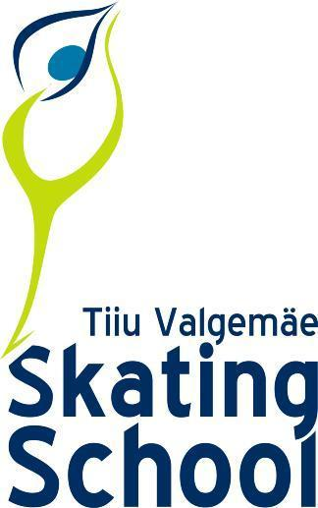
GLISS EXTRA 2022
ENTRY FORM
CLUB..............................................
Contact person …………………..
E-mail: …………………………….
Tel: ………………………………..

Please return by September 19, 2022

 | SKATERS NAME | DATE OF BIRTH  (date/month/year) | CATEGORY  A/B /Amateur | CLASS

GLISS EXTRA 2022
PLANNED PROGRAM CONTENT FORM
Please return by October 6, 2022
Club:
Category:
Skaters name:

PLANNED PROGRAM CONTENT

 | SHORT PROGRAM |  |  | FREE PROGRAM
1 |  |  | 1
 |  |  | 2
2 |  |  | 3
 |  |  | 4
3 |  |  | 5
 |  |  | 6
4 |  |  | 7
 |  |  | 8
5 |  |  | 9
 |  |  | 10
6 |  |  | 11
 |  |  | 12
7
8

